Membership Year ______________ DATE: _______________________
◻ Yes! I want to BECOME A MEMBER of the Lac La Biche Regional Humane Society & become part of the team working toward the humane treatment of animals in the Lac La Biche Region.
◻ Yes! I want to RENEW my membership with the Lac La Biche Regional Humane Society & continue to be part of the team working toward the humane treatment of the animals in the Lac La Biche Region.

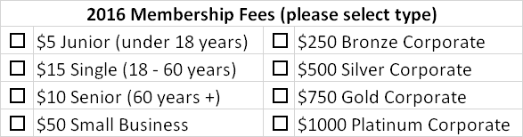

Membership privileges  for the LLBRHS include: | - 10% off purchaseat Colorful Critters  - Our semi-annual newsletter  - Voting privileges at the Society’s Annual General Meeting (excluding Junior members)  - A membership card  - Summary of Meeting Minutes  - Corporate members will receive a certificate for display

Enclosed is an additional donation of $_______________.
(Donations greater than $20.00 are TAX RECEIPT ELIGIBLE)

Would you like us to send you a receipt? ◻ Yes ◻ No
How do you prefer we correspond with you? ◻ email ______________________ or ◻ Hard Copy
email address

I am enclosing a total of $______________ ◻ Cash ◻ Cheque ◻ Money Order

Office Use Only:
Receipt # _____________ Value $ ____________
Membership Type: _________________________
New __________ Renewal ___________

NAME:
ADDRESS:
City: |  | Province: |  | Postal Code:
Phone #:
Please pay online or
mail completed form & payment to:

LLB Regional Humane Society
PO Box 2033, Lac La Biche, AB T0A2C0

(Charitable Registration No. 81750 2768 RR0001)

